### **Project 01**

### **Deploy a Database Server with Backup Automation**

**Objective**: Automate the deployment and configuration of a PostgreSQL database server on an Ubuntu instance hosted on AWS, and set up regular backups.

### **Problem Statement**

**Objective**: Automate the deployment, configuration, and backup of a PostgreSQL database server on an Ubuntu instance using Ansible.

### **Deliverables**

1. **Ansible Inventory File**



1. **Ansible Playbook**

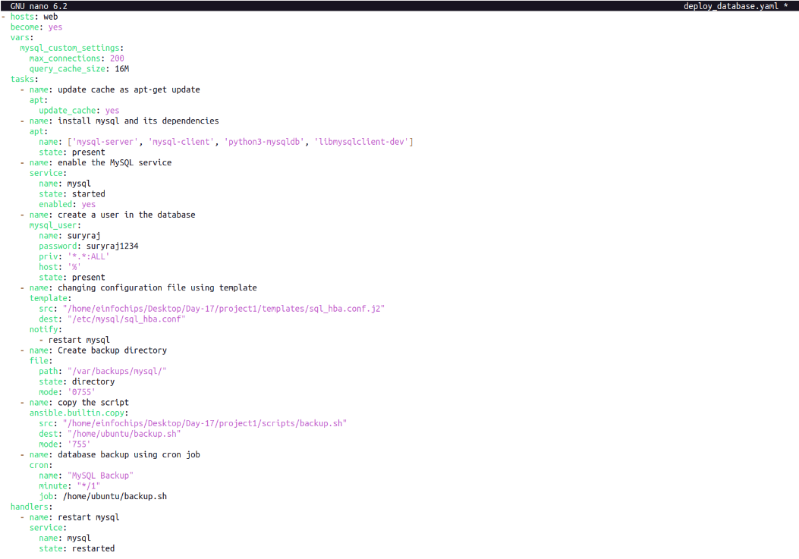

1. **Jinja2 Template**

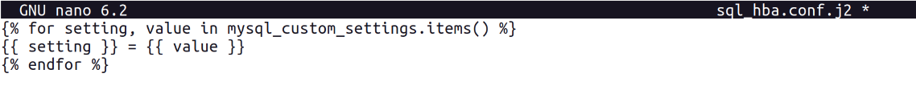

1. **Backup Script**

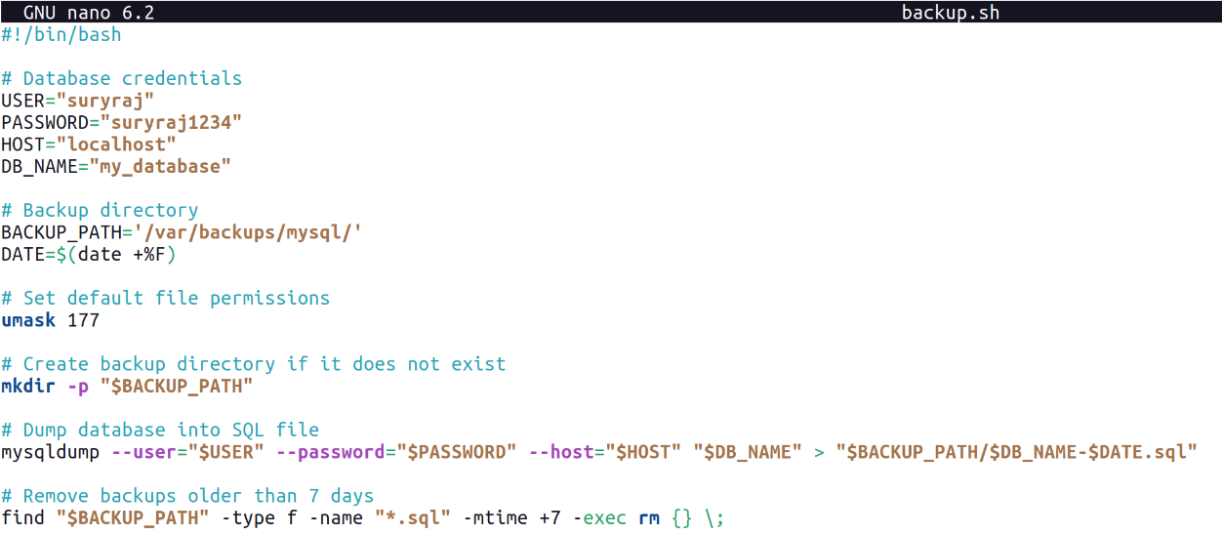

Run the playbook :

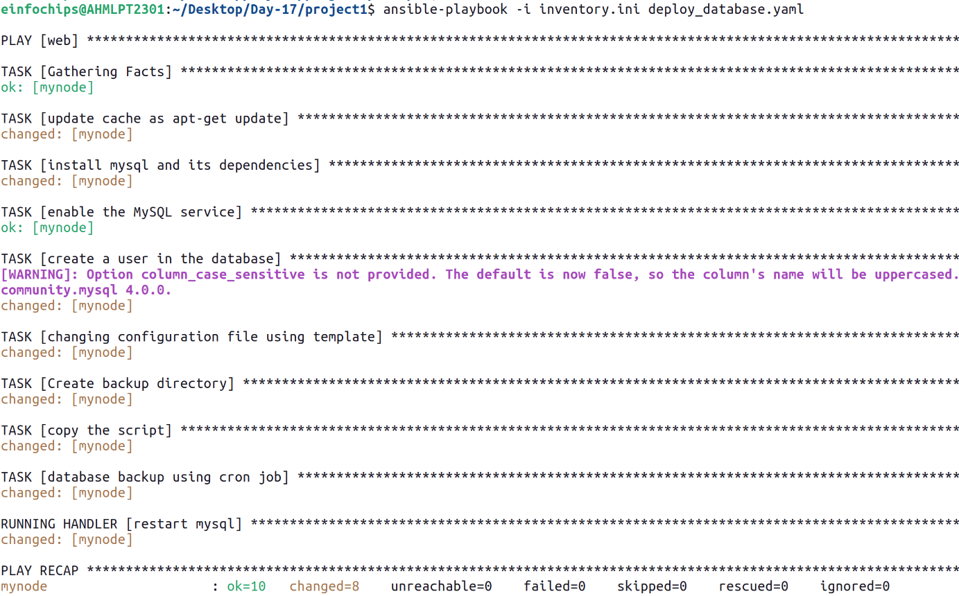



### **Project 02**

**Objective**: Automate the setup of a multi-tier web application stack with separate database and application servers using Ansible.

### **Problem Statement**

**Objective**: Automate the deployment and configuration of a multi-tier web application.

### **Deliverables**

1. **Ansible Inventory File**



1. **Ansible Playbook**

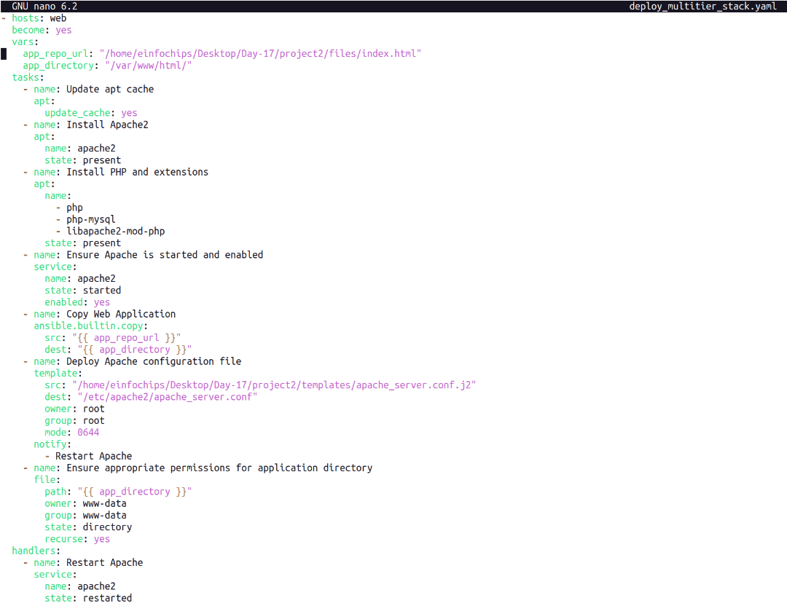

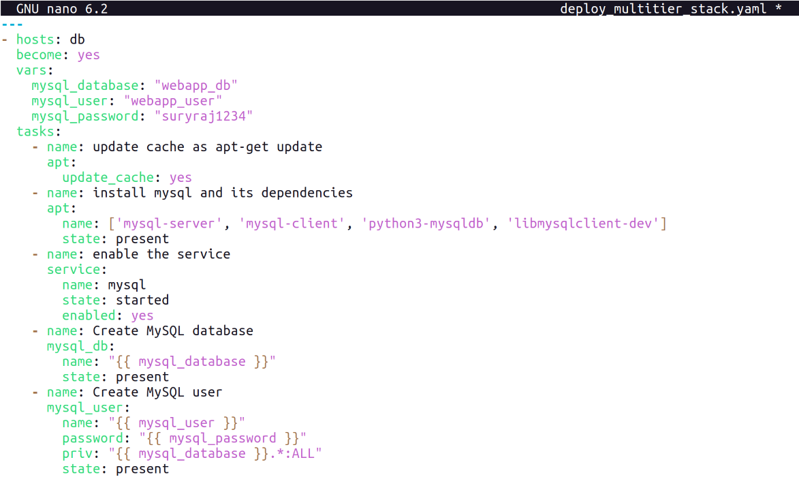

1. **Jinja2 Template**

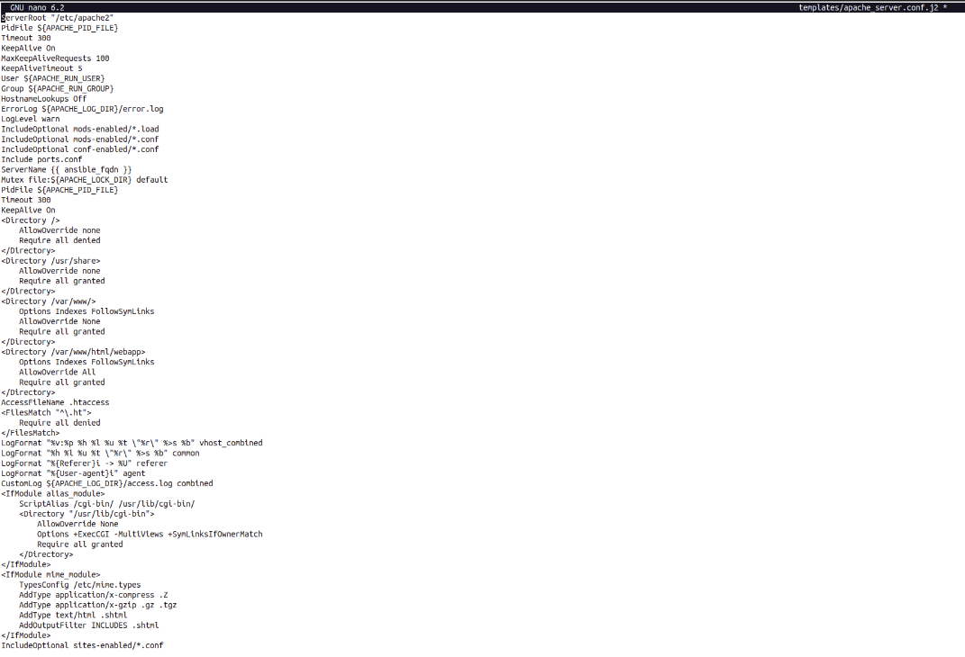

1. **Application Files**

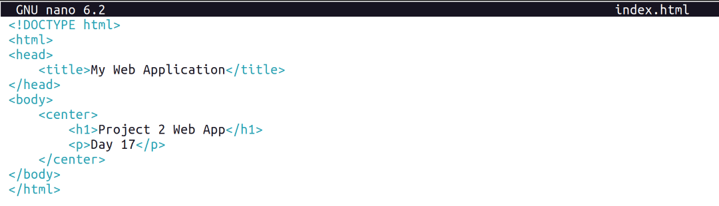

Run the playbook :

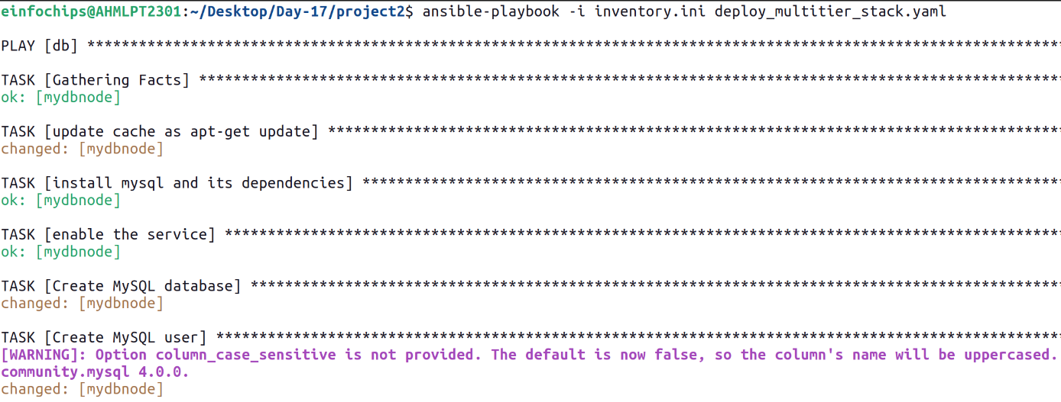

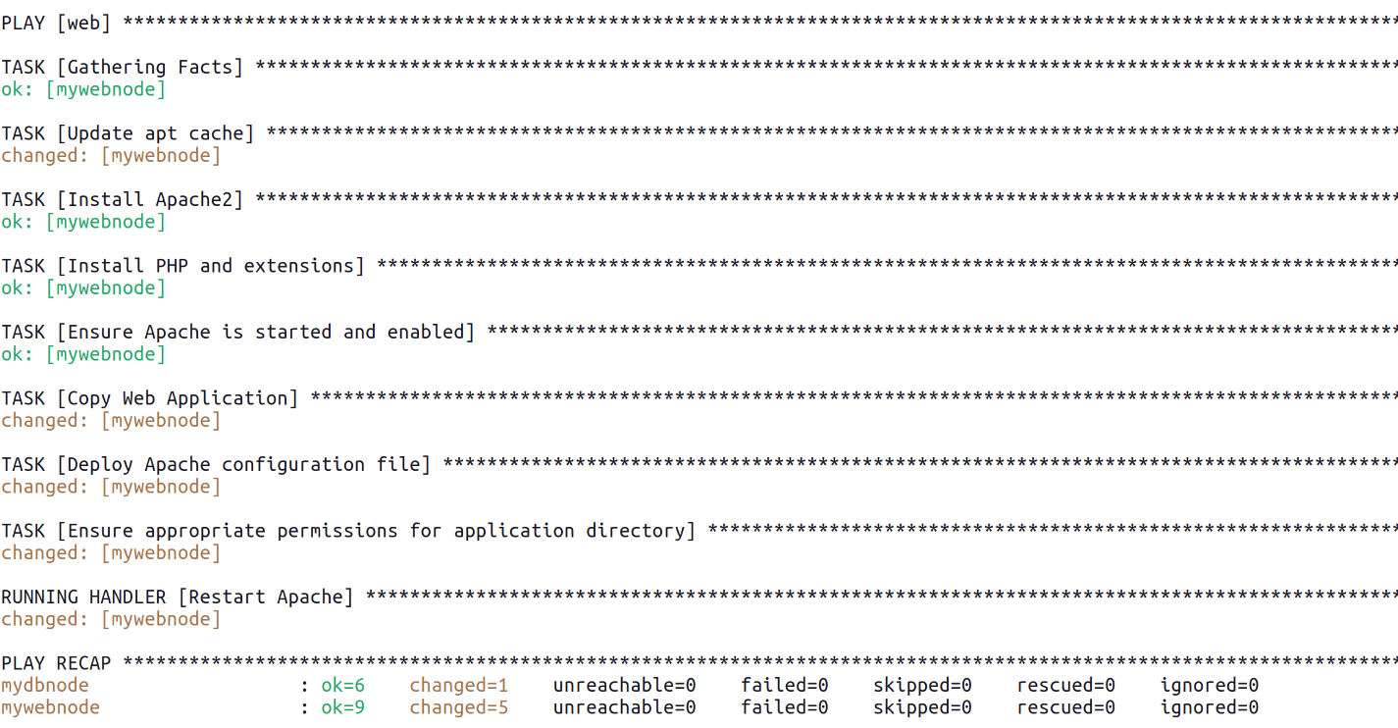

Output :

